1. Get API is implemented to perform fetch operation of sales record by filtering category and region.   
   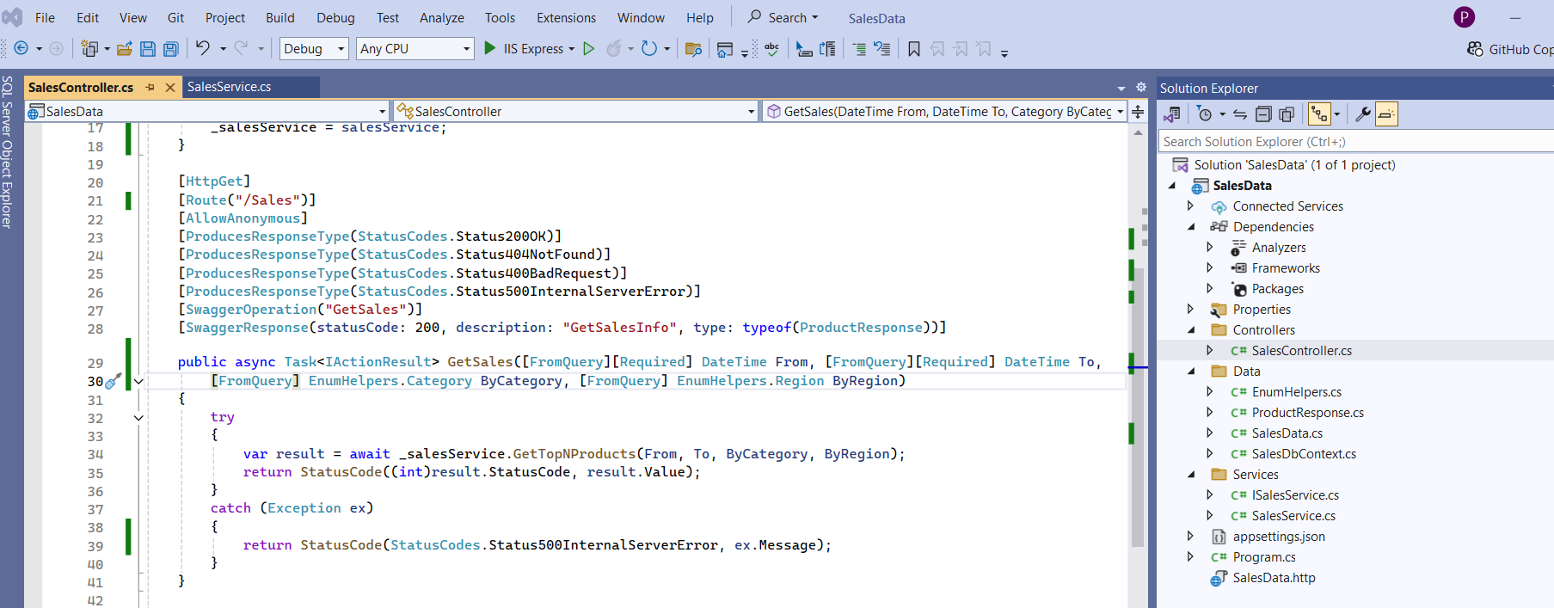  
   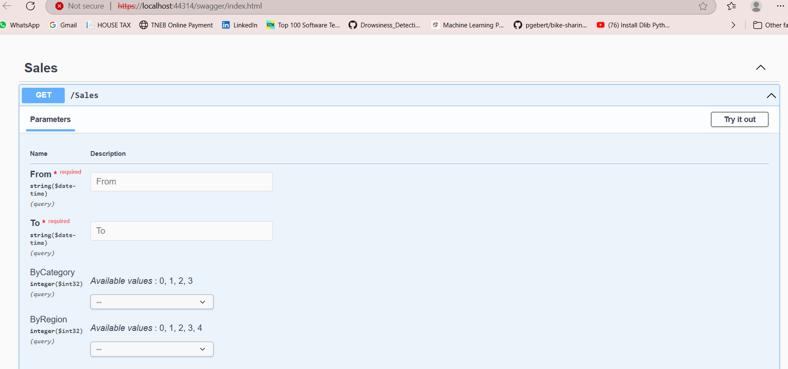  
     
   Response model:  
   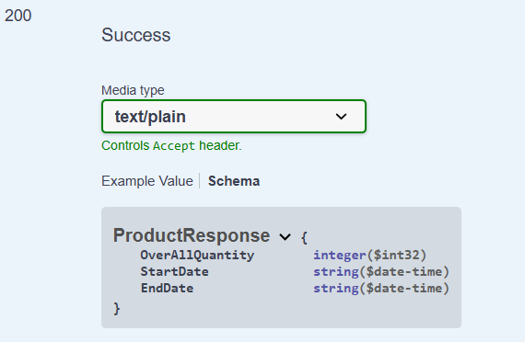
2. Database – SSMS 2019.  
   i) created table-> imported CSV -> staged table casted data type.

ii) Execute in the transaction

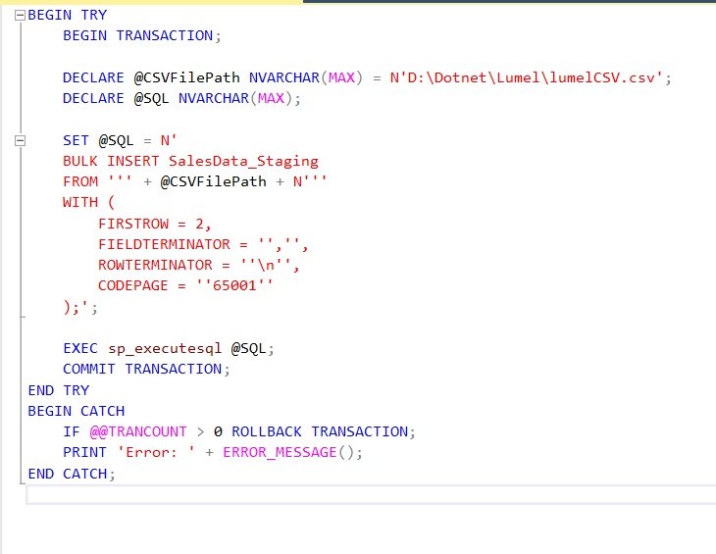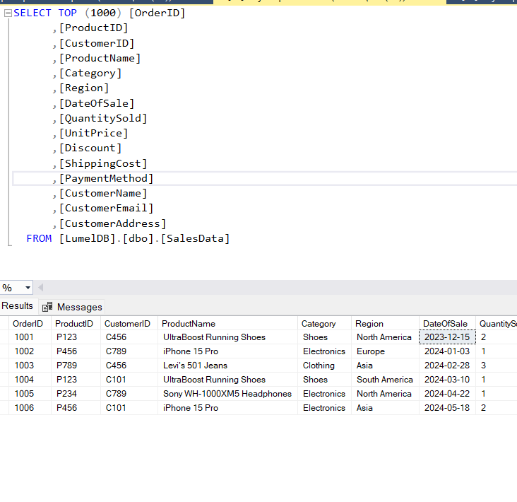

1. Console API can be created and hosted in Azure and set a trigger schedule Job for a interval of time to refresh the data and to check for the in comings.
2. Use of Ilogger in built, to log errors in console or azure appinsigths via connection string in configuration.